AAVS1 Sub-Array selection

Giuseppe Pupillo, 17 May 2018

In order to verify the origin of the signal coming from the horizon, that is visible in the images produced by Randall, it has been proposed to flag the antennas at the edge of the array. In fact, the outermost antennas should be shielded from that horizon signal by the innermost ones.

For this purpose, five different sub-arrays have been selected:

* Central
* North
* East
* South
* West

Each sub-array is defined by the center and radius of the circle. The elements outside of this circle are flagged in the data post-processing.

The four not centered sub-arrays are expect to receive the horizon signal only from the direction in which they are displaced, since they should be shielded only by the flagged antennas located in the opposite direction.

The switched-off, no-present and anomalous elements (Tab. 1) have been included in the list of the flagged antennas for all the sub-arrays.

|  |  |
| --- | --- |
| **Antenna Base #** | **Note** |
| 3 | not installed (the concrete base is empty) |
| 12 | anomalous low-level output only for the X-Pol |
| 16 | switched-off |
| 26 | switched-off |
| 41 | not installed (the concrete base is empty) |
| 120 | switched-off |
| 121 | switched-off |
| 128 | switched-off |

*Table 1 – Extra-flagged antennas*

The uv-plane coverage of each individual sub-array has been calculated has been calculated considering the phase center at the transit of the Sun on 04 May 2018 (HA = 0°, Declination = 6.042°) and 159 MHz frequency.

**CENTRAL SUB-ARRAY**

Selected area:

Center ENU [m] = -4.5, 0, 0

Radius [m] = 14.3

Flagged antennas = 96

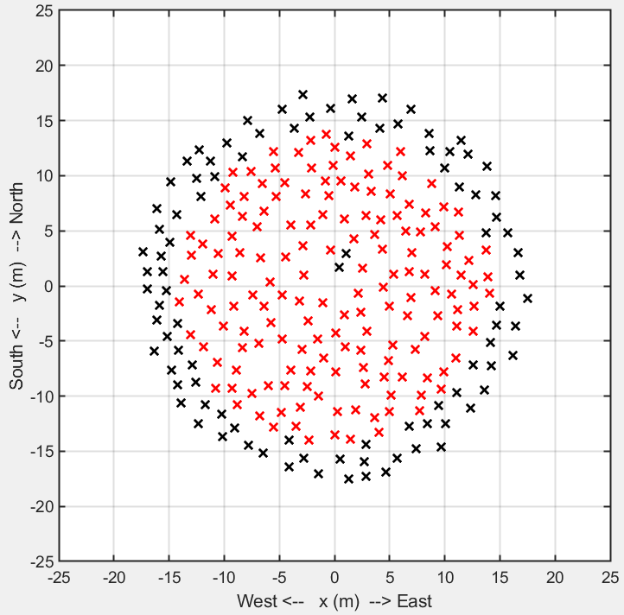

Map of the Central Sub-Array.   
The black crosses are the flagged elements.

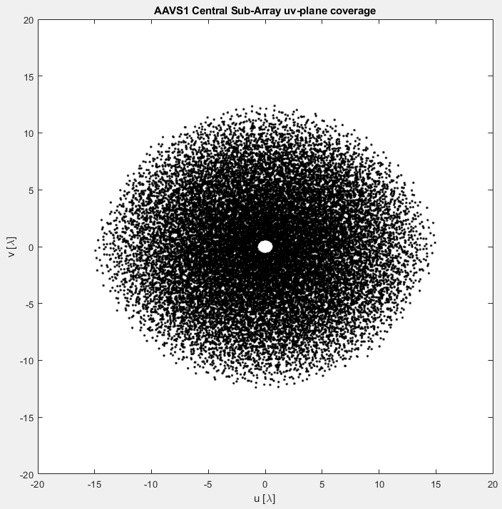

u-v coverage of the Central   
Sub-Array.

**NORTH SUB-ARRAY**

Selected area:

Center ENU [m] = 0, 4.5, 0

Radius [m] = 14.3

Flagged antennas = 105

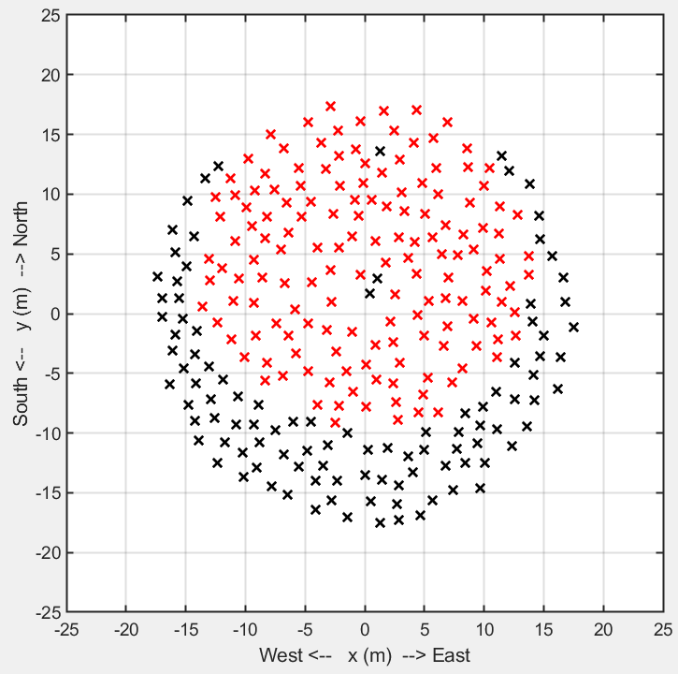

Map of the North Sub-Array.   
The black crosses are the flagged elements.

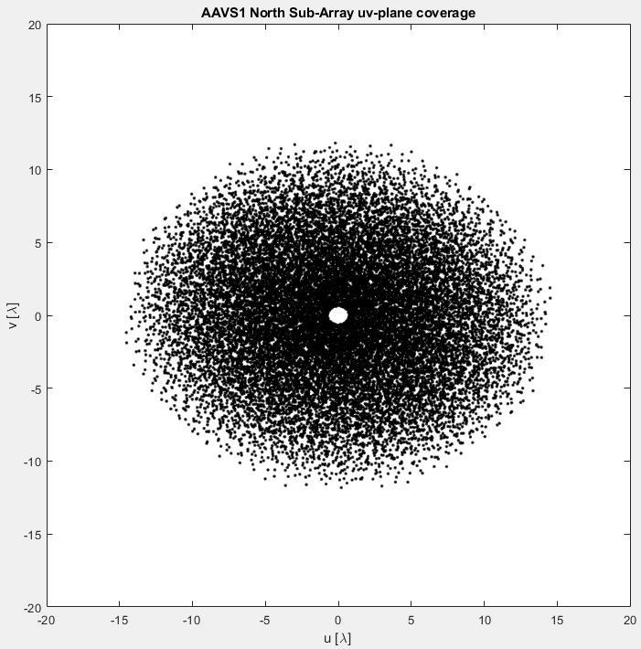

u-v coverage of the North   
Sub-Array.

**EAST SUB-ARRAY**

Selected area:

Center ENU [m] = 4.5, 0, 0

Radius [m] = 14.3

Flagged antennas = 109

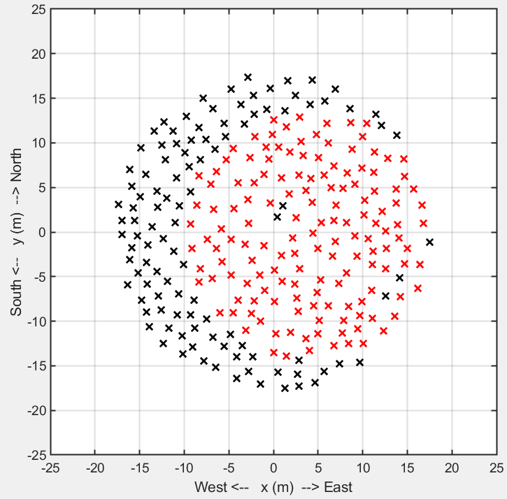

Map of the East Sub-Array.   
The black crosses are the flagged elements.

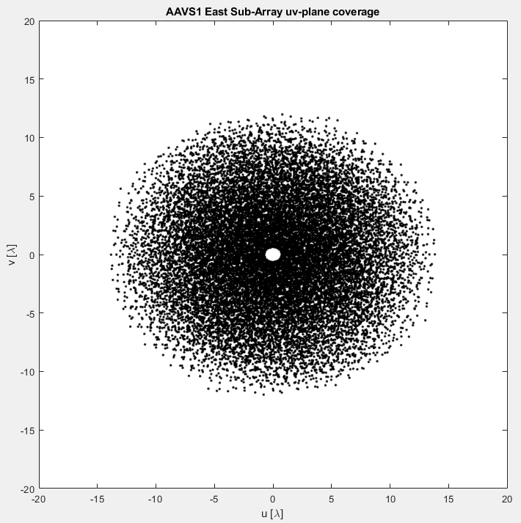

u-v coverage of the East   
Sub-Array.

**SOUTH SUB-ARRAY**

Selected area:

Center ENU [m] = 0, -4.5, 0

Radius [m] = 14.3

Flagged antennas = 102

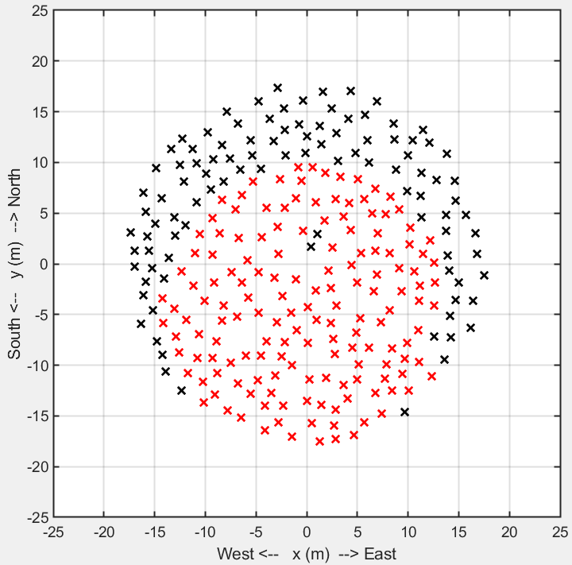

Map of the South Sub-Array.   
The black crosses are the flagged elements.

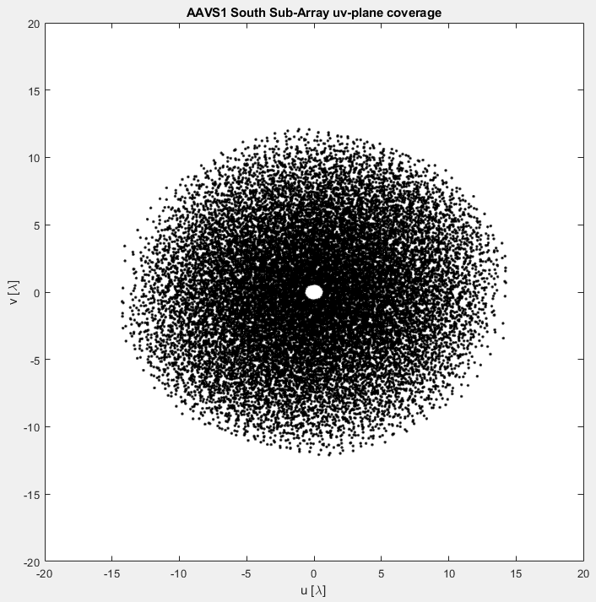

u-v coverage of the South   
Sub-Array.

**WEST SUB-ARRAY**

Selected area:

Center ENU [m] = -4.5, 0, 0

Radius [m] = 14.3

Flagged antennas = 96

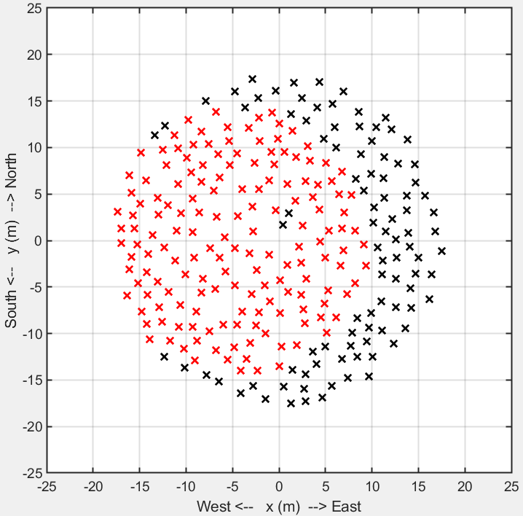

Map of the West Sub-Array.   
The black crosses are the flagged elements.

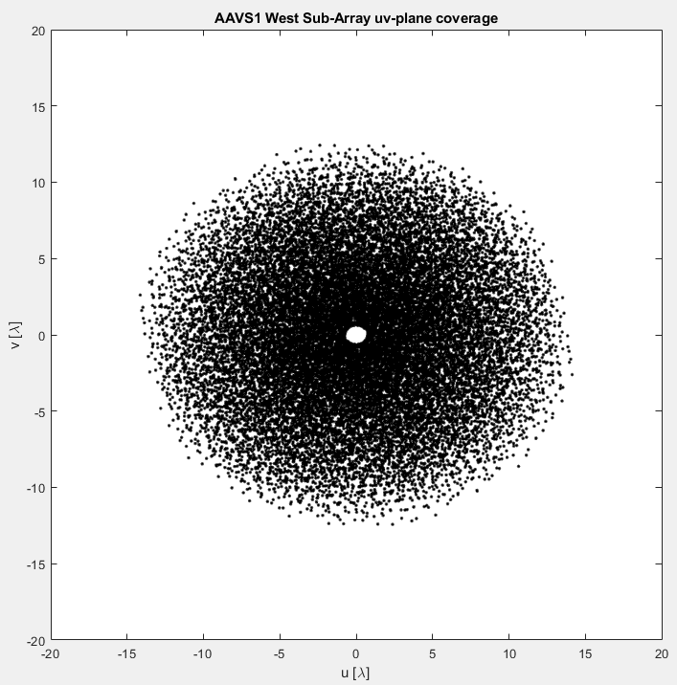

u-v coverage of the West   
Sub-Array.